MIDTERM REPORT

Michael-Angelo Yadao, 27415559

Nicholas Cierson, 27318014

Rahul Patel, 27199708

Kostas Zoitakis, 27393741

Muhammad Haseb Ellahi, 27437579

Faraz Yunus, 27489994

Amir Shawwa, 29271627

MECH 490: Capstone Engineering Design Project

02/11/2017

**Background**

Augmented reality is an up and coming technology which allows the interaction of virtual objects into reality. More specifically, the superposition of computer generated objects and information into the physical world [1]. This digital information may vary from a simple text being displayed to a complex computer-generated 3D model which is then projected into a heads-up display system giving the appearance that they are part of reality. The user of the augmented reality headset can interact with both the digital information and reality simultaneously as if they were one.

For our current system, there would be a stationary cube being displayed into reality via a screen viewer. This would allow the user to view the cube in all directions by simply moving around the cube and to view it from different perspectives with the help of a depth sensor. The current programmed AR headset can detect hand gestures allowing a more interactive interface between the cube and the physical world. This program can be further expanded to include more features but presently these are its capabilities.

**Problem Statement**

The biggest issue concerning the augmented reality technology is its cost, for example the latest headset created is the Microsoft Hololens with a price of $3999 [2]. The high cost is due to the technology still being in its early stage of development with studies being conducted into the understanding and implementation of augmented reality. With such a large sum, many may be discouraged to buy the headset, preventing or hindering the progress of augmented reality technology.

For our current headset, it is being designed as an open source system. In other words, the design would be made public for anyone to access and create their very own headset with the help of a 3D printer which is how our AR headset is being manufactured. With features that are not to overly complex, an average 3D printer would be able to do the job making it more accessible to everyone. Using a 3D printer to manufacture the headset would be time and cost efficient rather than using other manufacturing processes such as moulding or machining. There is also the issue of the hardware required to run an augmented reality headset. Which is why the components needed should be available to purchase and at a reasonable price. The Odroid XU4, intel realsense, the BNO 055 accelerometer and the screen can be found online with ease. Another concern would be the programming required for the AR headset, by making the design open source, the program would be downloadable and straightforward to use. By making the design and program open source, the public would be able to possess their very own headset at a much cheaper price since it will only require them to get the parts 3D printed and to purchase the hardware needed.

**Project Progress**

Before the designing phase of the AR headset could be started, some constraints had to be evaluated. For instance, there were three possible configurations for the headset: phone with a mirror, raspberry PI with a screen and the BNO 055 or the Odroid XU4 with a screen plus the BNO 055 and the depth sensor, ranging from the least to the most preferred configuration. The chosen configuration would determine the design of the headset. Ideally, it would be best if the headset designed could suit all three configurations. However, it was decided that the last configuration (the Odroid XU4 plus screen plus BNO 055 plus depth sensor) would be the desired one. The specifications of each of the hardware were researched, including their overall dimensions. With this known, the headset would be designed to incorporate those components. To date, a design has been made which is composed of four parts; headset base, top cover, back plate and back piece. This design has been made to include all four components of the configuration chosen. The 3D printing of these parts is currently being done, however, issues concerning the printing of the headset have occurred with an estimated print time of around 8-9 hours for the headset part. The 3D printers at the Technology Sandbox and the one of a team member were the devices being used but they have run into complications when printing it. One of the major problem was due to the long print time which caused the set screws of the extruder to loosen, shifting one of the axis’ of the print. A solution would be to split the headset base into two separate parts to reduce the print time and prevent printing problems. Both parts would then be joined back together to complete the headset. Another solution would be to use the EDML C’s 3D printer since it is more advanced and will likely be able to print the headset without any problems.

With an initial design and prototype of the AR headset completed, the next major deliverable is acquiring a screen viewer which would project the screen onto it. The old version in the possession of Dr. Charles Kiyanda has a screen viewer made from an opaque material which makes it difficult to see in the daylight. Further research needs to be done regarding the proper material for the screen viewer. A comparison would be done between the possible material to determine which would display the digital information clearly and accurately. When the screen viewer will be decided upon, the next step would be to incorporate it with the AR headset prototype and determine how it should be positioned to ensure the correct focal length. With the prototype complete, the analytical phase can begin. This consists of the various tests which needs to be done on the headset to ensure its functionality. One of the major tests will be based on the thermal management of the headset. With the possibility of using the headset for long periods of time, the components may overheat. Therefore, proper air and heat flow within headset must be maintained. This test would be done by first using a temperature gun to establish a baseline temperature inside the headset at different running times. With these data and the use of a wind tunnel, the proper air flow to keep the components cooled can be determined which will maintain them at a temperature below 60˚C. Additionally, a vibrations test is necessary to simulate the headset being worn. This test consists of placing the headset on a shaker with all the components inside and setting it at different frequencies to determine whether components will stay fixed in their position. Finally, a drop test to test the integrity of the headset by determining whether the components would break on impact. For this test the actual components would not be used. In conclusion, the focus of the remaining work to be done would be the analytical portion of the project which is the testing.

**Literature Review**

One of the most anticipated technology of this generation is the Augmented Reality headset/goggles (AR technology). This can be defined to connect the digital world with the physical world depending on the user’s needs and settings. More specifically, by adding digital information into reality through codes and algorithms which enables the user to do so [14]. One of the main characteristics of this technology is that it does not enable the creation of a spatial location but simultaneously adds digital information into the physical world via headset or goggles [14]. This digital information may include static data such as 3D models of objects or even dynamic ones depending on the user’s inputs into the device [14]. This technology enhances a person’s view of reality with the help of images, texts or other type of medium that are integrated into the real world through the device. This gives the impression that they are part of the physical world. Another aspect is that the user can willingly alter the physical world, making AR technology interactive by changing the information present to his suiting [14]. For example, this can be done by importing something from the digital plane into the physical world allowing the user to interact with his surrounding.  Everyone wearing an augmented reality device has their own perspective of the physical world that is being altered and the material being projected depends on the user’s current position [14]. For instance, when something is being changed in a specific area of the real world, this change will remain in that location even if the user looks and moves to a different direction with the headset. In short, these are the traits which makes Augmented Reality different from similar technologies.

Currently, there are many companies who have created their own augmented reality technology but the two largest companies which have created tools that utilizes this technology are Google with their application Tango and Microsoft with their Hololens [16]. For instance, Google has created and incorporated augmented reality into two mobile phones [17]. Some of the features included are the ability to interact with virtual objects into reality and with information appearing through the mobile phone that appear as to be part of the environment which can all be done by simply pointing the mobile device’s camera at a certain location [17]. Then there is the more advanced AR headset technology: Microsoft Hololens. This device combines both the digital and physical world together through their headset which enables an interactive environment to be created where holograms can be generated [15]. Microsoft Hololens would be the device that would revolutionize Augmented Reality.

**Essential and Unique Features of the Design**

In terms of design, there are several essential features we must make sure to incorporate into our augmented reality headset to ensure that our device can deliver a similar experience when compared to industry leading devices such as the Microsoft HoloLens. As such, the essential features we’ve determined necessary in our headset are:

1. Appropriate weight distribution: since the headset will be intended to be worn for long periods of time, the headset should have appropriate weight distribution close to 50-50 front/back so that there is no discomfort caused by most the weight being on one side. Furthermore, the weight of the device should be supported by the user’s head instead of the weight being on the user’s nose and ears.
2. Adjustability: the headset should be able to fit a variety of head sizes by having a mechanism that allows the internal diameter of the headset to be adjusted.
3. Appropriate thermal management: the augmented reality headset should not overheat causing unnecessary discomfort on the user. Furthermore, the headset should be passively cooled to not affect the user’s experience (fan noise, etc.).
4. Reliability: the headset should be sturdy enough to not break under normal everyday use.

In addition, the purpose of this capstone project is to add several unique features that would differentiate our AR headset from the rest of headsets in the market:

1. Affordability/Accessibility: the headset should primarily be made of easy to access and inexpensive material to keep the fabrication cost as low as possible.
2. Open source and Upgradable: the AR headset should be extensible by adding more a different set of hardware combination. The headset should be functional even when the hardware is swapped. For example, the headset should be functional using a Raspberry Pi or an Odroid XU-4 processor. It must contain standard hardware that anyone can purchase/access and it must use only open source software as it’s platform.

**Engineering Analysis**

Any product that enters the market has undergone some sort of engineering analysis to prove the product's design suitability and its practical application. This is the basis to prove that the functionality of the object being produced is as per the user needs. All aspects of the design will be evaluated in order to ensure the greatest user experience possible. A design should focus on these four main factors, safety, appearance, usability and cost. For the Augmented Reality headset (AR) capstone project, the team will perform an engineering analysis on the headset and the components of the headset. The tests that are planned are two thermal tests, a drop test, a vibration test and a stress test. The two thermal tests will allow the team to find out the time interval at which the AR headset heats up and conclude if the obtained time is suitable for the designs suitability. Also, the team will be able to better understand the comfort of the operating temperature and use the feedback to improve on this. The drop test will be performed to ensure that all the internal components are fixed well and do not get affected after dropping the headset. The goal is to ensure the functionality of the device after a certain impact (dropping from a standard human height). The vibration test will be used to simulate the stability of the device through movement of the head, sometimes sudden, to maintain functionality at the optimal level by normal use. The goal of using all these tests is to validate that the headset meets the user requirements. It needs to be comfortable, not getting too hot during use, and a good weight distribution. All this is important to ensure a great experience for the user.

**Test Results and Validation**

***Test 1 – Drop Test***

Objective

The objective of this test is to observe what occurs after the Augmented Reality (AR) headset is dropped from different heights.

Introduction

A robust design ensures that the products life cycle is greatly increased. Nowadays, products tend to fail from accidental drops, whether it be from an individual’s hand, from a table or an accidental slip. Our capstone team wants to ensure that our AR headset is robust and strong enough to avoid failure from accidental drops. To test for the robustness of the AR headset, a drop test will be done at different heights repeatedly to ensure the product remains intact.

Three heights are chosen due to the following:

* 0.75-1 meter: mimic an accidental drop from a table
* 1.75 meter: average height of male in Canada (worst case scenario, as average height of male is bigger than a female)
* 1.9 meter: Worst case scenario, to test the height of males (99 percentile)

Failure of this test will allow us to redesign our AR headset, such that the next iteration is more robust.

Procedure

1. Weigh the individual hardware components (Raspberry-Pi, Odroid XU4, Screen, Intel realsense camera R200, Adafruit BNO 055 (motion sensor))
2. Remove the hardware from the AR headset and replace it with test material to replicate the weight of the individual components
3. Drop the AR headset from a height of 1 meter and verify if the AR headset sustained damage. If failure occurs stop the test.
4. Repeat step 3, four more times
5. Repeat steps 3 and 4 at a height of 1.75 meter
6. Repeat steps 3 and 4 at a height of 1.8 mete

Results

|  |  |  |  |  |  |
| --- | --- | --- | --- | --- | --- |
| Height (Meter) | Trial 1 Failure (Y/N) | Trial 2 Failure (Y/N) | Trial 3 Failure (Y/N) | Trial 4 Failure (Y/N) | Trial 5 Failure (Y/N) |
| 1 |  |  |  |  |  |
| 1.75 |  |  |  |  |  |
| 1.9 |  |  |  |  |  |

Table 1: Test results from drop test

***Test 2 – Thermal Test***

Objective

The objective of this test is to note the operating temperature of the Augmented Reality (AR) headset. Additionally, we want to observe the air speed required to adequately bring down the temperature of the AR headset.

Introduction

One of the main concerns with the AR headset is that the user feels uncomfortable because it tends to heat up easily. We want to bring the temperature of the AR headset to an optimal range of 35 °F to 45 °F. To do so, we will run the AR headset to find the baseline temperature of the headset. The AR headset will be placed in a wind tunnel to establish the air speed required to bring the temperature of the headset within 35 °F to 45 °F. The air speed will allow the team to determine the type of fan required.

Procedure

*Part A*

1. Turn on the AR headset and allow it to run for an hour
2. Using a temperature gun, take the temperature of the AR headset.
3. If you notice that the temperature is not stable, allow the temperature to settle (Check every 15 minutes)

*Part B*

1. Attach a thermocouple to the interior of the AR Headset, and observe the temperature on the screen
2. Secure the AR headset inside the wind tunnel while the AR headset is running
3. Turn on the wind tunnel and bring the airspeed to 0.5 m/s
4. Wait a couple of minutes and proceed to observe the change in temperature as the air passes through the AR headset
5. Increase the airspeed in increments of 0.5 m/s until the temperature of the AR headset goes down to 35 to 45 degrees Fahrenheit

Results

|  |  |
| --- | --- |
| Temperature (°F) | Air Speed (m/s) |
|  |  |
|  |  |
|  |  |
|  |  |
|  |  |
|  |  |

Table 2: Test results from Thermal test

***Test 3 – Vibration Test***

Objective

The objective of this test is to observe the effects of vibration on the Augmented Reality (AR) headset.

Introduction

When in use, the AR headset will be subjected to several vibrational motions. To ensure that the hardware remains in place and does not come loose when in use, a vibrational test is done. The AR headset will be subjected to different frequencies (sin function) for certain periods of time. After completing this test, if there is any hardware which comes loose, additional mounts in the design will be required.

Procedure

1. Turn on the vibration machine and place the AR headset in the vibration fixture (H10 Labs)
2. Apply the sin function on the function generator
3. Increase the frequency of the vibration machine on the function generator by 100 Hz and let it run for 3 minutes
4. Observe the AR Headset as you increase the frequency (if the components start to shake)
5. Repeat steps 3 and 4 until the AR headset vibrates vigorously and observe what occurs

Results

|  |  |
| --- | --- |
| Frequency (Hz) | Observation (Failure or Not) |
|  |  |
|  |  |
|  |  |
|  |  |
|  |  |
|  |  |

Table 3: Test results from Vibration test

**Comprehensive Design/Validation System Diagram**

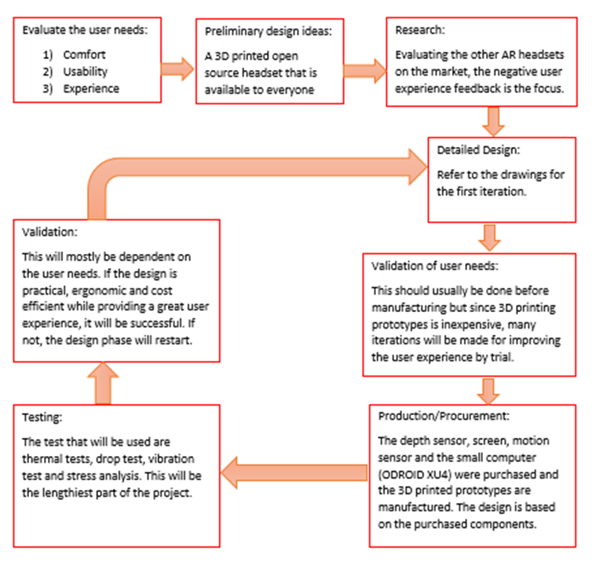

Figure 1: Design Validation Diagram

**Comprehensive Cost Analysis**

|  |  |  |  |
| --- | --- | --- | --- |
| Itemized Components | Purchased/Manufactured/Sponsor | Labour Hours | Cost ($) |
|  |  |  |  |
| **Display** |  |  |  |
| 5 in HDMI screen | Sponsor |  |  |
| Display Visor lens | Purchased |  | 10 |
|  |  |  |  |
| **Headset** |  |  |  |
| Headset base | Manufactured | 7 | 105 |
| Headband cushion and padding | Purchased |  | 8 |
| Adjustable Headband | Manufactured | 3 | 45 |
| Headset top cover | Manufactured | 5 | 75 |
| Back piece and back cover | Manufactured | 3 | 45 |
|  |  |  |  |
| **Sensors** |  |  |  |
| Adafruit BNO055 Orientation sensor | Sponsor |  |  |
|  |  |  |  |
|  |  |  |  |
| **Processors** |  |  |  |
| Raspberry pi 3 | Sponsor |  |  |
| Odroid - XU4 (Heat sink + Fan incl.) | Purchased |  | 120.57 |
|  |  |  |  |
| **Hardware** |  |  |  |
| Intel RealSense depth camera | Purchased |  | 153.36 |
|  |  |  |  |
| **Thermal Management** |  |  |  |
| Cooling Kit for rsbp 3 (heatsink +fan) | Sponsor |  |  |
|  |  |  |  |
| **Power and Connectivity** |  |  |  |
| 10000 mAh USB powerbank battery | Purchased |  | 20 |
|  |  |  |  |
| **Other** |  |  |  |
| Printing material (PLA) | Purchased |  | 90 |
| Wiring | Purchased |  | 20 |
| Velcro | Purchased |  | 4 |
| Fasteners | Purchased |  | 7 |
| Mirror | Purchased |  | 6 |
|  |  | Total Cost ($) | 708.93 |

Table 4: Comprehensive Cost Analysis

**Important Assembly, Operating and Maintenance Features**

The casing will be composed of 3d printed modules for adjustability and for it to be open sourced (adding new components). The casing is composed of three 3D printed components that will be assembled by press fit. The internal components will be fastened using bolts for sturdiness during use of the headset and to be easily removable. The wiring will be well managed by using covering them and ensuring that they are not out in the open to not interfere with the experience of using the headset. There will be a fourth 3D printed piece that will connect the straps from the back to the front of the head. It will allow the headset to be adjustable for extra comfort. A cushion will be added to the back piece and the back cover of the headset for convenience during use. It will also be disposable for it to be changed throughout the life cycle of the headset. Since the casing components are 3D printed, if anything breaks, it can easily be replaced. The screen will also be interchangeable if ever it becomes defective and needs to be changed. This is the main aspect of the design, it should be open source, components should be easily interchangeable for improvements or replacing defects. The design will be based on the lowest possible operating temperature to help the user use the headset for long periods of times if needed. Having a base of the functional components (screen, sensors, lens), the body should be able to easily be modified for comfort and to better the user experience. The current product must be used in a fixed space but the goal is to add a portable battery and make it portable. This will help the product be free of use in any space and not be constrained to being near a power source. Through the testing process, there will be many other aspects of the user experience that will be worked on for ease of assembly and operation.

**Product Specifications**

Overall dimensions of headset: 25 x 10 x 18 cm and overall weight: 470 g

**Processor**

ODROID-XU4 chip

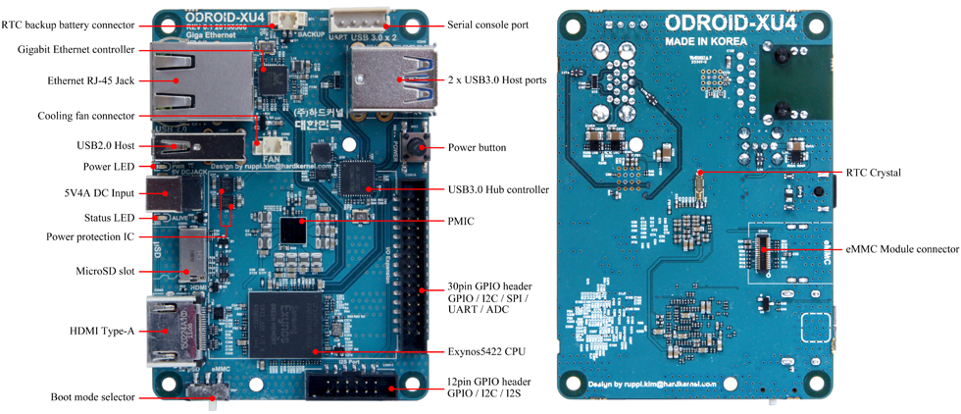

Figure 2: ODROID-XU4 board detail, adapted from [3]

|  |  |
| --- | --- |
| 2 x USB 3.0 | read SSD (273 MB/sec) write SSD (258 MB/sec) |
| Power input | 4.8-5.2 V (5V/4A Power supply recommended) |
| Processor | Samsung Exynos5422 ARM® Cortex™-A15 Quad 2.0GHz/Cortex™-A7 Quad 1.4GHz |
| Size/ weight | 83x58x20 mm / 38 g |
| WiFi | USB IEEE 802.11 ac/b/g/n 1T1R WLAN (external adapter) |
| Display | HDMI 1.4a |
| Software | Linux Kernel 4.9 LTS |
| Memory | 2Gbyte LPDDR3 RAM PoP (750Mhz, 12GB/s memory bandwidth, 2x32bit bus) |
| Ethernet port | Ethernet with RJ-45 Jack |

Table 5: ODROID-XU4 chip specifications [3]

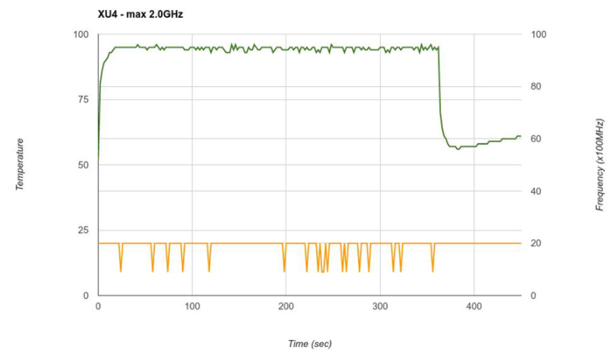

Figure 3: ODROID-XU4 operating temperature vs running time using active cooling, adapted from [3]

**Sensors**

Adafruit BNO055 9-DOF sensor

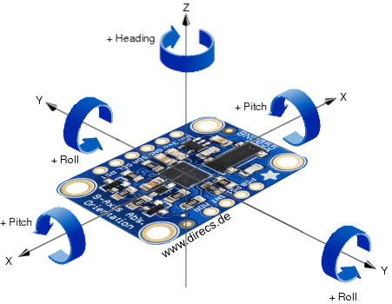

Figure 4: BNO055 axes of rotation, adapted from [4]

|  |
| --- |
| Absolute orientation on three axis based on a 360o sphere |
| Angular velocity on three axis rotation speed |
| Acceleration vector on three axis (gravity + linear motion) |
| Linear acceleration vector on three axis (acceleration – gravity) |
| Ambient temperature in oC |

Table 6: BNO055 Data output [5]

Intel RealSense R200 camera

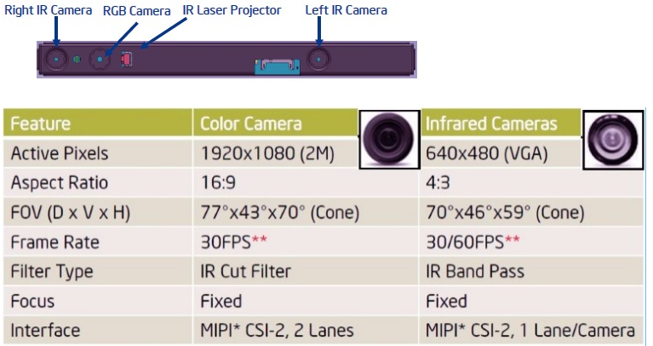

Figure 5: R200 camera specs, adapted from [6]

Capabilities: 3D Scanning, Speech recognition, person tracking, depth enabled photo and video, hand tracking, measurement, and scene perception.

**Display & Optics**

5-inch LCD 800x480 HDMI touchscreen: 12 V power supply, -20 oC to 70 oC operating temperature [7].

See through plastic visor

**Engineering Drawing**

See the end of the report for all relevant CAD drawings.

**Environmental, Safety and Human Impacts**

Any product being sold needs to meet several environmental and safety regulations. The Augmented Reality (AR) headset will comply to directives such as the European Union’s Restriction of Hazardous Substances directive, 2011/65/EU (RoHS) [8], the Registration, Evaluation Authorization and Restriction of chemicals directive, EC 1907/2006 (REACH) [9] and the Canadian Standards Association (CSA) [10]. The RoHS and REACH regulation ensure that certain hazardous substances which are harmful to the environment and humans are restricted for use in products. A thorough analysis will be done on the full bill of material of the AR headset to ensure that all components comprising the AR headset are RoHS and REACH compliant. Additionally, this will ensure that no part was inadvertently omitted from the analysis. Moreover, the AR headset will adhere to the Canadian standards association's, which will inform consumers that the product is safe for use and environmentally friendly.

The majority of our headset will be 3D printed out of ABS and, as a result, will have no significant safety or human impacts. In fact, ABS is a low cost plastic and is often used for prototyping samples before production. Natural colored (beige) and black ABS plastics have been approved by the FDA and are even compliant to be used in food processing applications. As such, they pose no major safety or human impacts. Finally, black ABS is also RoHS compliant and does not contain any of the 29 substances of high concern based on the European Chemical Agency [11].

**Appendix (Graduate Attributes)**

**Analogical Case Study**

Though augmented reality is a great new innovative technology which will be a market for further development in the years to come, many issues are still present and must be approached with an ethical, legal or social view. These issues must be held into account when engineering an augmented reality device to protect the user, the service provider and the society which surrounds them.

The largest area of social and ethical problems seems to be safety relating mostly to the operator of the AR headset device, as discussed in “The Real-Life Dangers of Augmented Reality” by Eric Sabelman and Roger lam. This report discusses some negative aspects of common augmented reality applications with available devices (HoloLens, Google Glass, etc.) and compares its civilian use to that of a military fighter pilot to draw parallels of how augmented reality should be implemented properly and safely.

First of all, the use of augmented reality requires the user to often switch their focus from real world objects in the distance to virtual objects displayed centimeters from their face [12]. This can lead to eye strain (especially to people who already have vision problems), but most importantly longer reaction times and more distraction from the real world, especially for users who do not use augmented reality often [12]. Secondly, augmented reality usually inhibits the user’s central vision or peripheral vision, sometimes both. While virtual objects or notifications are being displayed to the user, this can often cloud his central vision. In order to limit this factor, notifications and pop-ups tend to be displayed on the sides of the screen. However, this leads to the user’s peripheral vision being impaired which can be just as bad. It allows us to gather data about the distance and speed of objects toward or away from you, which central vision does not do very well [12]. Interfering with the user’s peripheral vision can lead them to miscalculate the relative motion of objects and could lead to the user stumbling and even injuring themselves [12].

Many things can be learned from the above article which we can apply to our own augmented reality device. The first would be to always use our device in a safe location and environment, where a reduced reaction time and being more easily distracted will not have potentially harmful outcome for the user. Obviously augmented reality has many uses, but regarding our specific usage, it will not regard any high risk locations such as streets with moving cars, high drops, or dangerous materials. In the advent of one of these factors being introduced, a second person not wearing any augmented reality device should accompany the user and serve as a spotter for any potential dangers. This type of problem is hard to deal with in an effective way as the usage is often left to the buyer of the product, so warnings should also be given about the increased risks in some sort of documentation accompanying our device to let the user know of the potential dangers. Finally, regarding the impairment of central and peripheral vision, the article mentions that this aspect was overcome in fighter pilot displays by showing the virtual items in the central vision area but having them be realistic and not simply graphics which will more easily distract the user [12]. For obvious safety reasons previously mentioned, the display of objects in peripheral vision will be limited to a strict minimum in our device to allow the user to have the best possible vision of the real world and its dangers.

**Contemporary Practice**

When reading through “Virtual & Augmented Reality – Understanding the race for the next computing platform” research report by Goldman Sachs, many market trends and standards are identified which are becoming important staples for the augmented reality industry and market. The aspects will be important for future augmented reality device design and will be able to provide crucial information and insight for our augmented reality project.

The most seemingly obvious market and industry trend would be that all computing is being driven towards head mounted devices, or also commonly called headsets [13]. As can be seen with already existing examples of the Microsoft HoloLens and Google Glass, the entirety of the device is worm on the user’s head and allows for good mobility and motion. The device is self contained, fully portable (which implies it being comfortable and lightweight) and does not have any exterior connections. This is the most practical way to implement and use augmented reality technology for the user and is very convenient. Furthermore, the report by Goldman Sachs also identified 9 use cases for the technology which will have the largest impact on the market. These would be military, engineering, education, video games, live events, video entertainment, healthcare, retail and real estate [13]. This would imply that the industry focus has shifted to support applications in the aforementioned areas, and that augmented reality devices should be able to support functions required and many or all of these sectors.

Given this information, our augmented reality solution should have its place in the market. Firstly, our device is a head mounted one, which follows one of the major trends of the industry. Though as of now it needs to be plugged in to a power source (which implies the device is not mobile), it is already in our plans to make our device fully self contained and mobile, not requiring any external connections for our final iteration. The hardest aspect of the solution to this issue will be having the power source contained in the headset and having an appropriately long usage time before needing to be plugged in to recharge. Furthermore, after seeing the markets which AR will impact the most and noticing the large number of applications for augmented reality, it would be a smart idea to not limit the functionalities of our device and have it be multi functional. This way, it could be adapted from a video game use (for example) to a engineering use without too many complications. Finally, having the requirement that our headset be open source and easily reproducible (3D printed), this would imply that our device would be on the very low end of the price scale.

Given our expected low production cost, if our device can be made to be multipurpose and can be mobile and self contained, we believe our final product can find its place in the augmented reality market because of the previously mentioned factors. It would be an accessible entry level device, which could then be adapted fairly easily to new applications as the user’s uses for the headset evolve.

**References**

[1] A. B. Craig, “What is Augmented Reality?,” in *Understanding Augmented Reality.* Burlington, MA: Morgan Kaufmann, 2013, ch. 1, pp. 1-37.

[2] Microsoft. Hololens [Online]. Available: https://www.microsoft.com/en-ca/hololens/why-hololens

[3] Hardkernel co., Ltd. “Odriod platforms.” ODROID | Hardkernel [Online] Available at: <http://www.hardkernel.com/main/products/prdt_info.php?g_code=G143452239825&tab_idx=2>

[4] Knapp, Autor Markus. “The Adafruit BNO055 9-DOF Sensor IMU Breakout does not make it easy - or does it?” DIRECS, Available at: [www.direcs.de/2017/07/der-adafruit-bno055-9-dof-sensor-imu-breakout-macht-es-einem-nicht-leicht-oder-doch/](http://www.direcs.de/2017/07/der-adafruit-bno055-9-dof-sensor-imu-breakout-macht-es-einem-nicht-leicht-oder-doch/)

[5] “Adafruit BNO055 Absolute Orientation Sensor.” Overview | Adafruit BNO055 Absolute Orientation Sensor | Adafruit Learning System, Available at: <https://learn.adafruit.com/adafruit-bno055-absolute-orientation-sensor/overview>

[6] “Specifications for the Intel® RealSense™ Camera R200.” Intel, Available at: [www.intel.com/content/www/us/en/support/articles/000016214/emerging-technologies/intel-realsense-technology.html](http://www.intel.com/content/www/us/en/support/articles/000016214/emerging-technologies/intel-realsense-technology.html)

[7] 5 inch LCD Screen TFT Module,800X480 VGA Video AV Driver Board, Available at: [www.buydisplay.com/default/5-inch-lcd-screen-tft-module-800x480-vga-video-av-driver-board](http://www.buydisplay.com/default/5-inch-lcd-screen-tft-module-800x480-vga-video-av-driver-board)

[8] "RoHS - Restriction of Hazardous Substances", ec.europa.eu, 2017. [Online]. Available: http://ec.europa.eu/environment/waste/rohs_eee/index_en.htm. [Accessed: 29- Oct- 2017].

[9] "REACH - Chemicals - Environment - European Commission", ec.europa.eu, 2017. [Online]. Available: http://ec.europa.eu/environment/chemicals/reach/reach_en.htm. [Accessed: 29- Oct- 2017].

[10] "CSA Group", CSA Group, 2017. [Online]. Available: http://www.csagroup.org/. [Accessed: 29- Oct- 2017].

[11] "ABS", Plastic International, 2017. [Online]. Available: https://www.plasticsintl.com/datasheets/ABS.pdf. [Accessed: 29- Oct- 2017].

[12] E. Sabelman and R. Lam, "The Real-Life Dangers of Augmented Reality", IEEE Spectrum: Technology, Engineering, and Science News, 2015. [Online]. Available: https://spectrum.ieee.org/consumer-electronics/portable-devices/the-reallife-dangers-of-augmented-reality. [Accessed: 31- Oct- 2017]

[13] ]"Profiles in Innovation, Virtual & Augmented Reality: Understanding the race for the next computing platform", Goldmansachs.com, 2016. [Online]. Available: http://www.goldmansachs.com/our-thinking/pages/technology-driving-innovation-folder/virtual-and-augmented-reality/report.pdf. [Accessed: 31- Oct- 2017]

[14]  A. B. Craig, “What is Augmented Reality?,” in Understanding Augmented Reality. Burlington, MA: Morgan Kaufmann, 2013, ch. 1, pp. 1-37.

[15] Microsoft. Hololens [Online]. Available: https://www.microsoft.com/en-ca/hololens/why-hololens

[16] H. Ling, “Augmented reality in reality,” vol. 24. IEEE Computer Society, 2017, pp. 10-15.

[17] Google. Tango [Online]. Available: https://get.google.com/tango/